**Term Project**

This project uses the concepts of Inheritance and Polymorphism to implement a payroll system.

(Payroll System Modification): Modify the payroll system of the figures shown below to include an additional Employee subclass called PieceWorker that represents an employee whose pay is based on the number of pieces of merchandise produced. Class PieceWorker should contain two private instance variables; wage (to store the employee’s wage per piece, a double precision floating point number) and pieces (to store the number of pieces produced). Provide accessors and mutators for the private instance variables. Provide a concrete implementation of method earnings in class PieceWorker that calculates and and returns the employee’s earnings by multiplying the number of pieces produced by the wage per piece. Override the toString method exists in the Employee class to allow it to print firstName, lastName, socialSecurityNumber, and wage for each employee. Modify the PayrollSystemTest class to create an array of Employee variables to store references to objects of each concrete class. You will find six (6) files that have been attached for your convenience:

1. PayrollSystemTest (Need to modify only one line of code to create a new instance of PieceWorker)
2. Employee (base class), SalariedEmployee (subclass), HourlyEmployee (subclass), ComissionEmployee (subclass), BasePlusComissionEmployee (subclass).

Here’s a sample output of the code running:

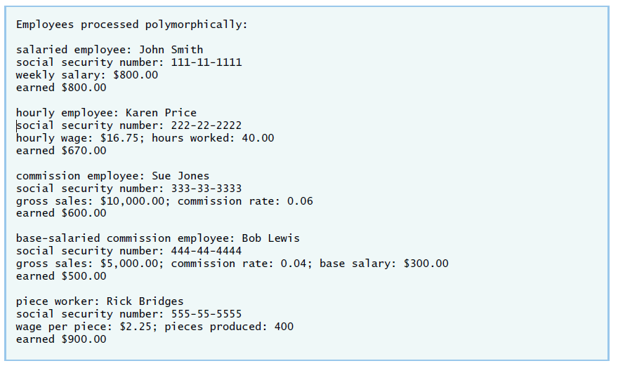

Things to keep in mind when implementing your PieceWorker class:

* The PieceWorker constructor should call the superclass Employee constructor to initialize the employee’s name.
* The number of pieces produced should be greater than or equal to 0. Place this logic in the set method for the pieces variable.
* The wage should be greater than or equal to 0. Place this logic in the set method for the wage variable.
* The main method must explicitly create a new PieceWorker object and assign it to an element of the employees array.

**Deliverables: Submit all your 7 classes in a .jar project to the designated Assignment folder in CougarView).**

